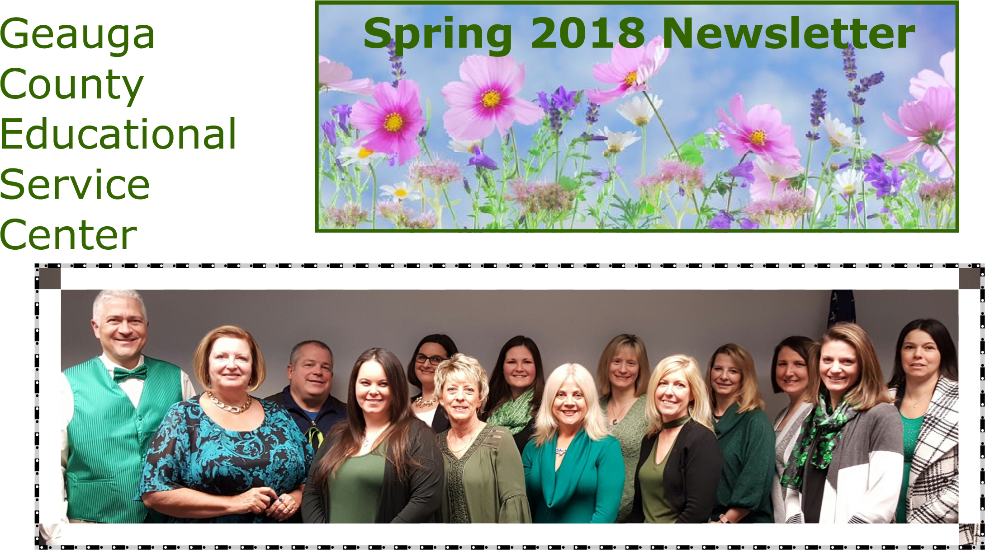

Dear GCESC Staff and Schools,

It is hard to believe we are almost to April and spring break is finally here. We have had many exciting events and programs happening in Geauga County. Please take time to read through the Geauga County Educational Service Center’s spring newsletter. The articles are celebrations of our wonderful students, families, schools and programs.
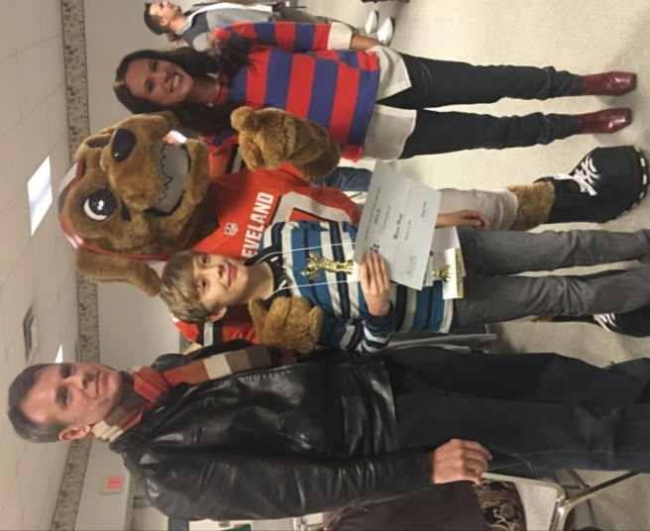
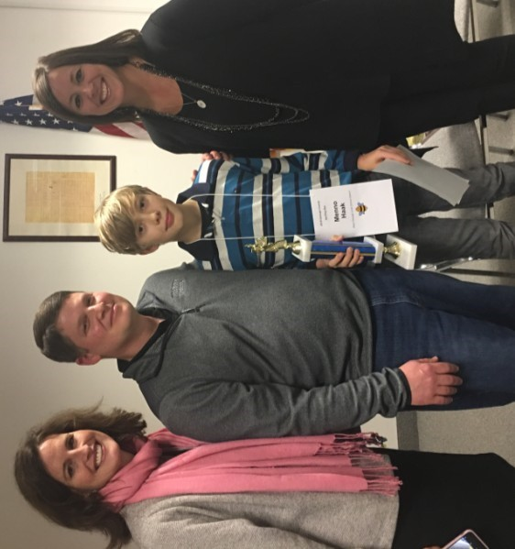
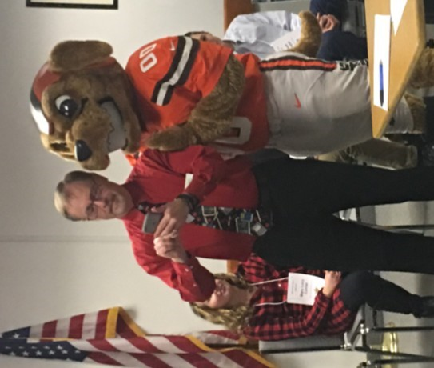
As we enter into our last quarter this school year, I want to take time to thank all of you for your hard work and dedication to the students we educate in Geauga County and beyond. Please enjoy time with your families and friends during spring break, as it is time to take a breather for a moment ~ relax, head south, and best of all enjoy some treats that a special little bunny will be dropping off.
County Spelling Bee Winner

CONGRATULATIONS to
Menno Haak, 10 year old
from the West Geauga
School District for winning
the Geauga County
Spelling Bee. The county
spelling bee is open to
students through the
eighth grade. Each dis-
trict in Geauga County
holds a spelling bee and
enters their winner into
the county spelling bee.

Please remember that influence you have on your students and never underestimate the impact you have on them every day.
Jennifer A. Felker
Superintendent
Geauga County Educational Service Center

Preschool ~ Alanna Hruska

April showers bring May flowers! The daffodils are sprouting, the birds are chirping, and the preschool students are ready to play outside without coats, hats, gloves, and snow pants! The Geauga County Educational Service Center preschool students have been a busy bunch over the past several months. The preschool students have been working on their letters, numbers, counting, colors, writing their names, singing songs, and much, much more!
The second window for the Early Learning Assessment (ELA) has opened up and teachers are in the process of gathering data in 10 Learning Progressions for each student on their caseload. This Ohio Department of Education assessment is utilized to determine kindergarten readiness. Early childhood educators will share this information and other student specific information at the upcoming spring parent/teacher conferences. There are Early Learning Assessment parent and educator resources located at: http://education.ohio.gov/Topics/Early -Learning/Kindergarten/Early-Learning-Assessment
The Geauga County Educational Service
Center has opened up enrollment for the 2018-2019 school year. Next year, there will be preschool locations at Ledgemont Elementary School in Thompson, Jordak
Elementary School in Middlefield, and the Metzenbaum building in Chesterland. There are role model spots available in several locations, please call Alanna Hruska at 440-729-0137 for enrollment information.
Check out the Geauga County Educational Service Center Early Childhood Program website for more information and resources! http://www.geaugaesc.org/ EarlyChildhoodPrograms.aspx

Are you an early childhood educator or parent looking for quality digital resources for early learners ages 3 through 5? Visit the INFOhio Early Learning Portal located at https://www.infohio.org/early-learning. Each resource supports the Ohio’s Early Learning and Development Standards. The free INFOhio Early Learning Portal helps preschool children:
- Learn letters, numbers, & basic knowledge;
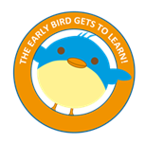
- Interact with other children and adults;
- Engage in meaningful play; and
- Develop focus and problem-solving skills.

Preschool Classroom Highlights!
Jordak Elementary: Students were learning through play in centers! Some students were selling pizza in the kitchen area, building castles out of blocks, playing board games, building farms with animals and tractors, etc.
Ledgemont Elementary: Colors, colors were everywhere! Students were creating color-specific projects using everyday items!
Maple Elementary: On those rainy days, the students spent time in the sensory room swinging and jumping to get the wiggles out!
Metzenbaum Center: The preschool students were ‘driving’ cars and ‘beeping’ at their friends as they were in Miss Carol Columbo’s music class!
Park Elementary: Students in Ms. Beth’s class created colorful parachutes out of coffee filters and the students in Ms. Kristen’s class created adorable sailboat crafts!

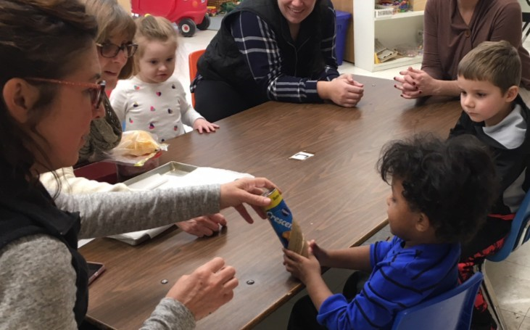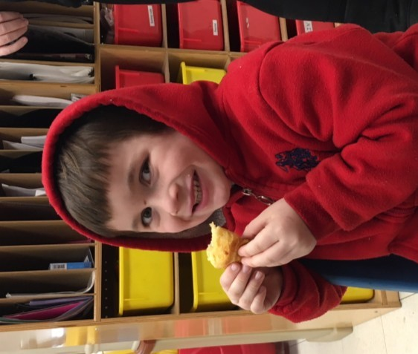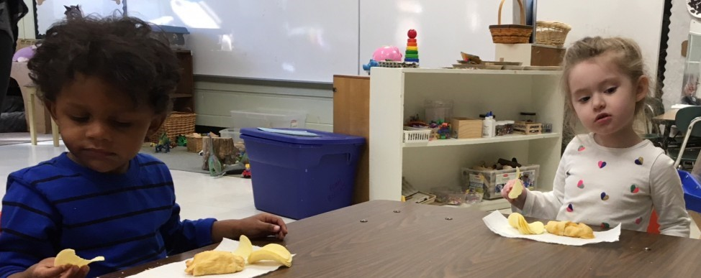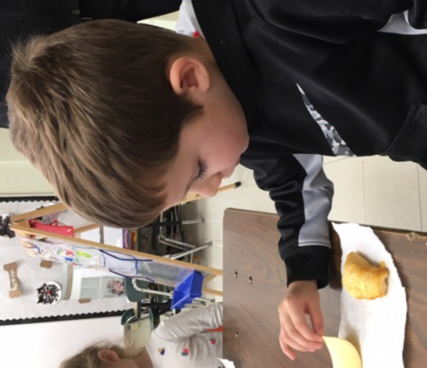

Making Crescent
roll ham &cheese
sandwiches.

Gaitway High School ~ Phil Hatton

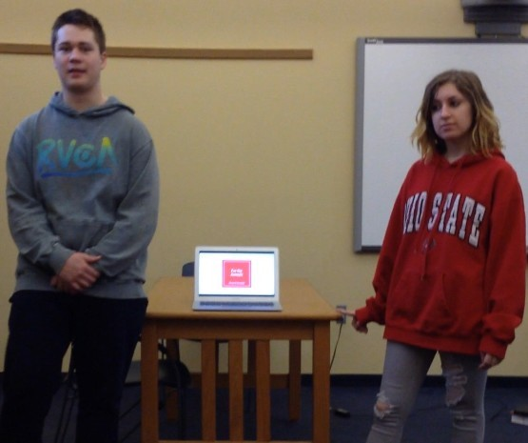
Our Winter has been busy, aside from being interrupted by snow days. We added several students this semester and they have been good additions to our school. Students continue to be creative during Project
Based learn-
ing (PBL) days
each week.
Most recently,
students iden-
tified an un-
sung hero that
they admired or were inspired by, and then put together a presentation about how they could support them.
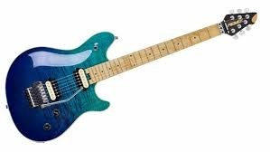
Students also earned a PBIS/PAR reward in February. For 15 days, each student could accumulate points toward attending a field trip to the Rock and Roll Hall of Fame. Points were awarded for their PAR ratings in each class, for turning in their phones during class, and for showing improvement in their PAR scores. At the end of the 15 days, every student was qualified to go! So, our visit to the Rock Hall was awesome.
We started with a presentation called “Fight the Power”, which was about the influence of rock music on social issues. After the presentation, we ate lunch, then spent the afternoon touring the hall.
We recognized two students as Students of the Month. Chana F. was named the student of the month for January for her hard work, her ability to problem solve and her attention to being accountable. Our February student of the month is Andrew C. who started with us in January. He is always polite, willing to do extra, and interested in learning.
Students were able to visit Lakeland
Community College in January with Ms. Barnhill and Job Training students continue to excel at their job sites. Another group of students will visit Kent State-Geauga Campus
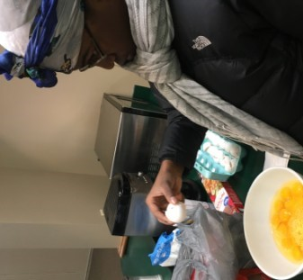
later this month. We currently have students at six different sites, plus our Transition Options 1 students who work in the Fieldstone stables and are an important part of their daily routine. Transition Options 1 and 2 students do a Life Skills lesson on Fridays. Typically, they do some cooking that they later share with everyone. We have enjoyed quiche, brownies, and tacos prepared by these students. Ms. Barnhill is also teaching an Art class that students are enjoying. They have done painting, crafts and some ceramics.
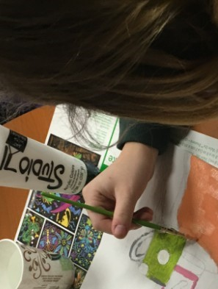
Student artwork is beginning to adorn our Gaitway walls.
At the end of March and be-
ginning of April, we will begin taking the Ohio State tests, also know as the End of Course Exams. May 18th will be our annual Gaitway Graduation recognition.

Donna Cook ~ Director of Special Services & Accountability
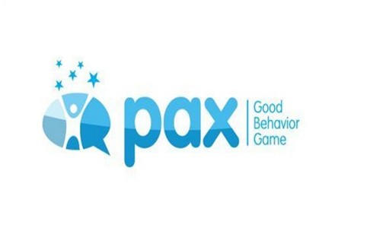
The Geauga County Educational Service Center in conjunction with the Geauga County Board of Mental Health sponsored a PAX Good Behavior Game training for teachers. Participants from 4 different counties packed the conference room in building 8 to learn how to institute PAX in their classrooms. The PAX GBG helps teach students, especially in the younger grades to self-regulate their behavior. PAX GBG reinforces prosocial behavior, increases psychological flexibility, limits problematic behavior and reduces toxic influences in student’s lives. Teachers were taught the brain science behind the game, along with all of the kernels and cues needed to play the game. Most importantly, all left with a tool bag filled with everything needed to start PAX in their own classrooms.

Carrington School ~ Michael Abraham
Frozen Falls  Continuing the Carrington School’s | community, and with the proceeds earned, we will purchase, create | Academics & Physical Fitness
sonal changes taking place on a field trip to view Blue Hen Falls in  the Cuyahoga | Geauga County  ESC’s Carrington School Program and the Carrington Youth Academy residential facility the students | had the opportunity to earn a field trip to PlayCLE. This was an exciting indoor fitness related field trip that students earned through the school’s
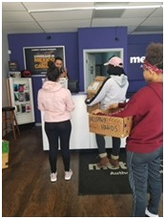
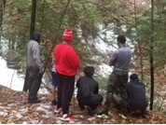
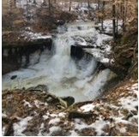
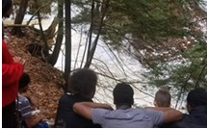
focus on Northeast Ohio natural and donate care Students continue their academic resources, bags to those in progress, including earning high
Valley at its frozen
state.

HELPING
H.A.N.D.S
.

male residential need of a hand”. school credits through a combination of on-line instruction and blended
students had
Implemented as a learning classes. As part of increas-
the opportunity joint project between ing academic achievement, students
to observe sea-
have netted approximately $168 PBIS incentive program targeting from collecting and selling recycla- increasing academic and quality perbles. They have already begun formance. While at PlayCLE stuputting together care packages for dents were challenged mentally, local shelters. The students have physically and emotionally by facing completed the whole process from many fears and physical challenges start to finish, including visiting the to complete the course. Some of the recycling center to see how recy- favorite and most challenging activiclables are sorted and weighed ties included the Ropes Course, the
Carrington Youth Academy and into the facility, writing letters to Ninja Warrior Carrington School are participating businesses collecting donations for Course and the in the Youth Empowerment Grant the care packages, and making Zip Line.
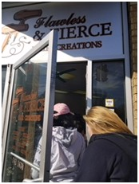
project. Female residential students recyclable boxes to have developed the following pro-place with local ject, described in their own words: vendors to support “Our goals as the Helping their cause.
H.A.N.D.S. leaders is to help the community and give back to others.
We are trying to eliminate two prob-

lems with one cause: collecting and
recycling waste throughout our
CONGRATULATIONS TO MEGHAN HULL
Meghan Hull is a Berkshire School District English teacher that was selected as the Geauga County 2017-2018
Innovative Teacher of the Year. Ms. Hull has spent her entire 14 year teaching career at
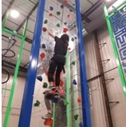
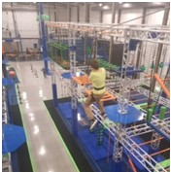
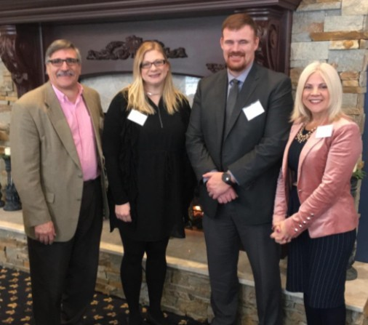
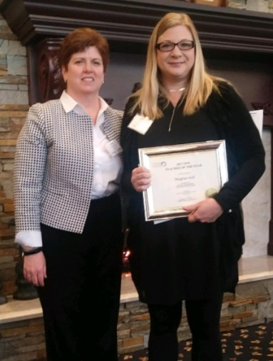
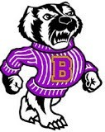
Berkshire. She has taught Senior English, Journalism (I, II, III), Creative Writing, Drama, Speech, and Yearbook. This year she is using a self-created team teaching model where she “pushes-in” with subject area teachers so as to add her knowledge of technology to benefit that day’s class but also to help that specific teacher to learn the technology through repetition so they can then use it on their own for future needs. She is currently developing standards for student tech trainers to assist other students and staff as well. Mary
L-R: John Manfredi, Berkshire Board McFarland, Sr. Talent Manager at Kinetico presented ^{Member; Meghan Hull, Berkshire} this award to Meghan at the All Boards Breakfast on
High School English Teacher; John
Stoddard, Berkshire Schools Supt; March 21st, 2018. Kinetico will sponsor Meghan Jennifer Felker, Geauga County ESC $1,500.00 to attend professional development op-
Mary McFarland and Meghan Supt.
Hull portunities.

Jennifer Klock, ~Nursing Supervisor
Come one, come all! School Nurses, Speech Therapists, Vision Specialists, or any school personnel that would like to be trained or refresh your training on how to perform a school hearing and/or vision screening. The Ohio Department of Health will be offering a Hearing & Vision Training at the Geauga County ESC! Follow the ESC website for the date and times in April!

On-Site Group Hearing and Vision Training
The Ohio Department of Health, Children's Hearing and Vision program, offers separate hearing and vision screening trainings. There is no registration fee for these trainings and no continuing education credits are given.
On-site group trainings will be provided by ODH staff, time and resources permitting. A minimum number of eight participants is required; however, no more than 25 participants can be scheduled per session.

The hearing screening training is scheduled separately and requires two hours of classroom instruction and hands-on training.

The vision screening training is scheduled separately and requires three hours of classroom instruction and hands-on training.

*If you are interested in hosting this training for your school or district, follow the link below….

http://www.odh.ohio.gov/odhprograms/cfhs/hvscr/On-site%20Group%20Trainings.aspx

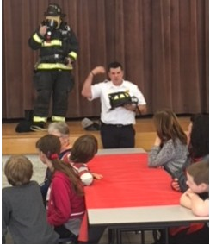
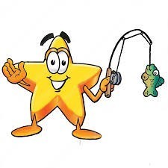
S.T.A.R.S. ~ Dana Eggers

S.T.A.R.S. GIVES BACK
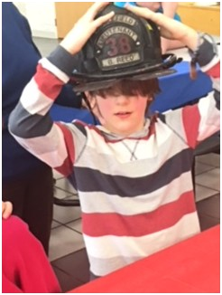
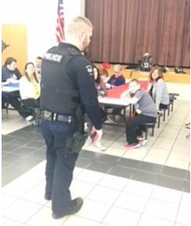
This year our S.T.A.R.S. Middle and High School students have been working at ‘giving back’ to the community this year. Classrooms have scheduled visits to community locations in order to raise awareness of helping others in need. Our students have made donations to the pets at Rescue Village and raised $250 for a donation to Habitat for Humanity.
(216) 410
-
2879
or
dana.eggers@geaugaesc.org

Cardinal classrooms scheduled a fire and police visit earlier this
month. Our students were given the opportunity to interact with police and fireman in a safe, non-emergency situation. Students were actively engaged and clearly enjoyed conversations with the volunteers from these organizations.

FUNDRAISER EVENT
We invite you to attend our Annual Fundraiser event! SHINE LIKE THE STARS
event will occur Saturday, April 28th from 6pm-10pm at Berkshire Hills Golf Course. Tickets are $35.00 per person or $250.00 for a table of 8. We promise a fun & delightful event, full of prizes and entertainment. Who’s Charlie, a local band, will be there playing some fun oldies music. Contact Dana Eggers for tickets, AUTISM AWARENESS
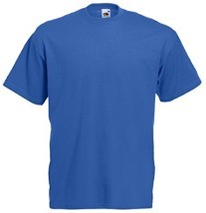
World Autism Awareness Day is April 2nd. Wear BLUE to support ALL individuals who are diagnosed with Autism.
S.T.A.R.S. teachers are beginning preparation for Autism Awareness activities that will be occurring during the month of April. Thank you to ALL of the districts that support our students and house our program. We are very lucky to work within such amazing and supportive districts.

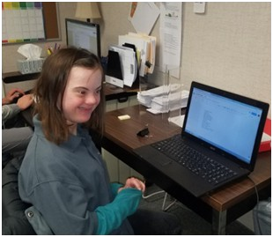
JOB TRAINING PROGRAM - (Job Training from a student’s perspective)
My name is Katherine Devon- with kids. I also like UH and meet new friends. I think shire I am from Kenston. I am Geauga where I unloaded the employers should keep having a full time student in Job dishwasher conveyor, I liked us (students) in the GCESC Training Program West. I like that. I also worked at UH Job Training Program. the job training program, I like Geauga in the summer. the jobs and the job coaches.
I have tried a lot of different I learned how to fold laundry in jobs like Bed, Bath, and Be- a lot of different ways at yond, The ESC West Geauga Heather Hill. They want the Preschool, and Geauga laundry folded a certain way. County ESC offices. I also Also, I have learned to follow like wearing a uniform. directions and use good com munication like eye contact. I
My favorite job so far is the learned a lot of different jobs. GCESC West Geauga Pre- The Job Training Program is a school because I like working good place to learn job skills
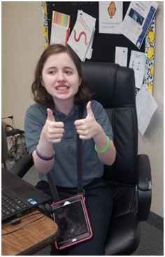
My name is Megan My favorite job site so far is tions, follow a work schedDonohue from Kenston. I UH Geauga and CVS phar- ule, and how to be in the am a full time student in macy. At the hospital I community and see people Job Training Program unload the dishwasher con- you know. I also made a reWEST. I work at a lot of veyor and put away clean sume and practiced interdifferent jobs like UH dishes. When I was at CVS viewing. Geauga, Geauga County I checked expiration dates ESC, Heinen’s, and The and stocked the shelves. Weils Senior Community
Living Center. In the past, At Heinen’s, I learned to I worked at Rescue Vil- package cookies with my lage, Natural Essentials, job coach Mr. McG. I have and Fellowship Bible to count them, put them into Church. I liked working at the container, and label the all the jobs I have had. containers. At my job sites,
I learned to follow direc-

CAREER ASSESSMENT ~ Mandi Baggett
The GCESC is excited to offer a new service this school year – Career Assessments!
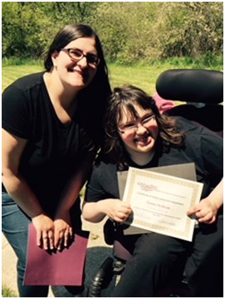
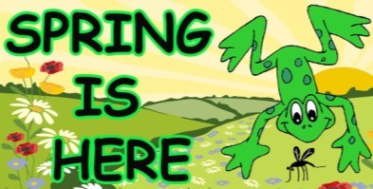
Career Assessments are available to all students at all ability levels. During the Career Assessment process, multiple assessments are given to the student in order to gather information about his/her PINS (preferences, interests, needs, strengths), career interests, career preferences, work aptitudes, postsecondary goals, employability skills, functional/ independent living skills, and learning style. Input is also provided by the family and members of the IEP team. Different package options and assessments are available for each student, depending on factors such as age and disability. Career Assessments are beneficial for several reasons:
- They provide baseline information for students who are just beginning to think about postsecondary goals, such as at age 14, or for older students who have not yet had vocational experience.
- They provide information to the student, family, and other IEP team members about the student’s preferences, interests, and abilities.
- They provide information to the student, family, and other IEP team members about areas in which the student needs to grow in order to meet postsecondary goals.
- Results can be used to guide career exploration and to help the student, family, and other IEP team members make decisions about programming.
- Results can be used to create a transition plan that is specific to the individual stu-
dent.

TRANSITION SERVICES ~ Sarah Drewlo

Ms. Drewlo provides the Work Study course to high school students receiving IEP services. Students earn credit and a grade for working in a competitive integrated setting while earning a wage.

Transition Activities upon request
Career Exploration
Administration of AATA
College and Career Readiness assessment and search
Resume Building
Job Search
Interview practice
Transition and job leads
Career Development/Multi-Agency Backwards Planning

Projected Expanded Transition Services for 2018/2019 Work Study Course (3 hour elective course)
Student Internship Program (1 semester/elective course)
Transition Consult II
Job Placement/Retention Services
Tier 1- TC included job leads, placement assistance
Tier 2- Job Coaching is offered as a support to ease the transition into employment

ACHIEVE PROGRAM ~ Robin Ludwig

We have so many exciting things going on in Geauga ACHIEVE! Students are visiting Hale Farm
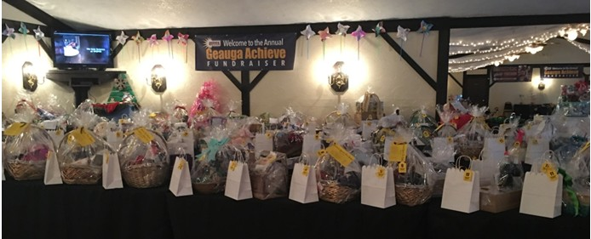
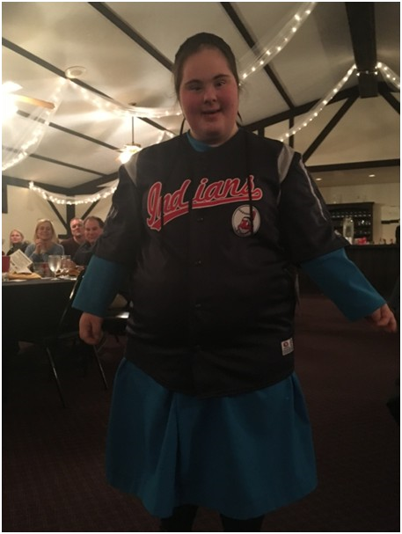
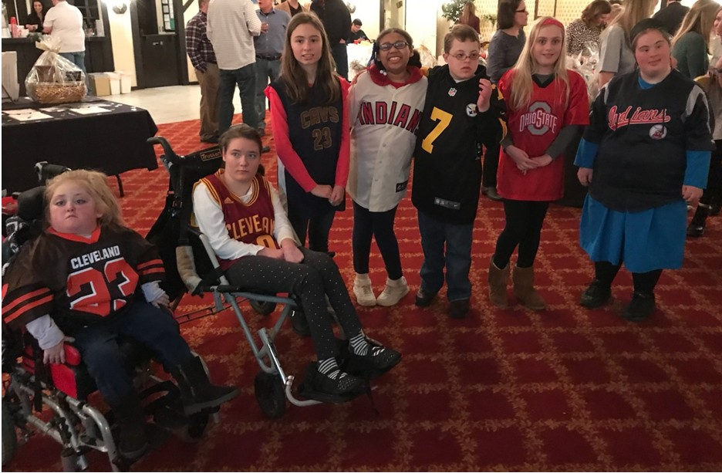
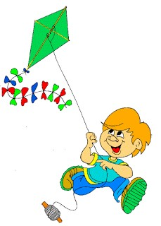
later is week, preparing for 6th grade camp, finishing up with Alternate Assessment, and of course working on the usual academics and standards. However, the big excitement in Geauga ACHIEVE this month was our Annual Fundraiser on March 10th! What a wonderful time we all had planning and preparing for this great event. There were many auction baskets, silent auction items, 50/50 raffles and balloon pops. Of course the highlight of the night was having seven of our ACHIEVE students take to the run way and model jerseys from sports teams for a live auction! The kids had a wonderful time, the crowd cheered, and funds were raised for the classroom. Thank you to everyone who came out and supported our students and staff at this amazing event!

